# ECE 5630 Fast Convolution

Aaron Pettit

12/6/2018

# Introduction

This lab compares the algorithms of a time domain filter and fast convolution using the FFT and the overlap-save or overlap-add method. Plots and some characteristics are given for each of the algorithms

# Filter

FIR filter specification

* 256 coefficients
* Lowpass filter
* Passband of 300 Hz with unit gain
* Stopband of 400 Hz
* Sample rate of 11,025 Hz

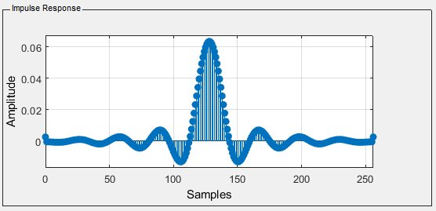

Figure h[n] Impulse Response

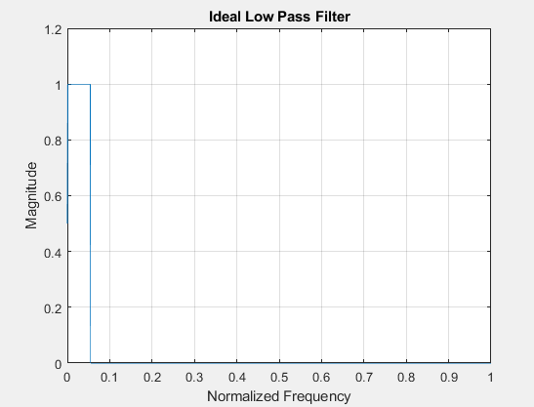

Figure Desired H(s) Frequency Response

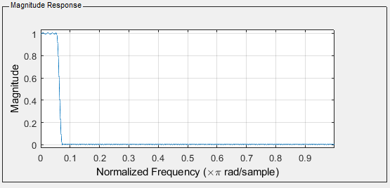

Figure Actual H(w) Magnitude Response

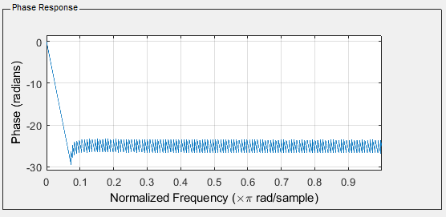

Figure Actual H(w) Phase Response

# Time Domain Filter